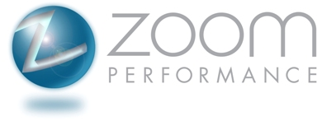
Women’s Intermediate MTB Camp
June 10th, 2012 9am-1pm
Lake Ahquabi State Park, Indianola, Iowa
Cost: $75, includes lunch
Sign up here: http://www.active.com/event_detail.cfm?event_id=2039225

Reach the next level in your racing and riding through expert instruction in the following skills:
- Cornering – Learn how to carry more speed into and out of corners
- Shifting – Find the right gear at the right time and learn why cadence matters
- Braking – Use braking to more efficiently navigate the trail rather than to kill your momentum and speed
- Positioning – Choose the best position possible for climbing and descending
- Bike Handling Skills – Control your bike in slow-riding situations
This is camp for women riders only! You should have your own mountain bike, clipless pedals, and at least two years of riding experience. This is not a beginner clinic - if you've attended our fall beginner clinic, this is the next step to becoming a better rider and/or racer!

Instructors Include:
- Abbie Durkee: Zoom Performance Coach
- Julie Kirkpatrick: Zoom Performance coach

