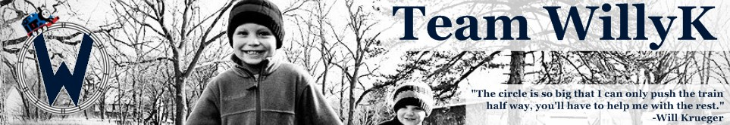
Cinco de Mayo Most Interesting Bike Ride
“I don’t always ride a bike, but when I do it’s on Cinco de Mayo”
Benefiting The Leukemia & Lymphoma Society
Saturday, May 5 – Registration starts at 11:00AM
Ride Starts at Flat Tire Lounge in Madrid
303 South Madison. Madrid, IA 50156
Flat Tire Ride Details:
Brian & Brad Krueger along with the Flat Tire Lounge in Madrid will be hosting a Fundraiser for the Leukemia & Lymphoma Society via bicycles on May 5th from 11am to 5pm. The ride will start at the Flat Tire in Madrid with stops in Slater (Night Hawk Bar & Grille) and Kelley (Crossroads Tavern). The route is around 26 miles and we will have the bike route maps upon your arrival. The cost is $25 at the door. There will be a raffle, prizes, and a silent auction. Registration is from 11am-noon. Ride starts at noon. Things will get interesting!

Stay thirsy, my friends!
$3.00 Dos XX Draws
$8.00 Dos XX Pitchers
$4.00 Margaritas
$4.00 Mexican Car Bombs!

