Road Rules:
Eight Tips for Safer Cycling

Be Seen

To be seen, “stick out”. Wear colorful clothing by day. Wear reflective gear and always use a front light and rear flasher at night.

Go With the Flow

Always ride in the same direction as traffic, never in the oncoming lane or on the sidewalk.

Play By the Rules

Always obey stop signs and traffic signals.

Take the Road Less Traveled

When it comes to choosing cycling routes, don’t think like a motorist. Go for roads with less traffic and lower speeds, not the “straight shot”.

Be Considerate

Want to get respect on the road? Give it! Never obstruct traffic by riding abreast. If traffic is piled up behind you, pull off the road in a safe spot to let vehicles get by.

Get Your Bike Out of the Gutter

Don’t ride on the very edge of the road. One wobble and you’re in the ditch. Unless there’s a bike lane or a wide, clear shoulder, ride to the left of the white line, roughly along the path that a motor vehicle’s right wheels would travel.

Sometimes It’s Right to Go Left

Sometimes safety requires riders to “claim the lane”. In a busy downtown area, ride toward the middle of the lane to avoid getting doored. Climbing a curvy mountain road, a driver may see you sooner if you move toward the middle of the travel lane as you first hear the approaching vehicle, then back to the right as the vehicle nears.

At Intersections, Do What the Cars Do

Most bicycle-car collisions occur at intersections. If you’re turning, use the same turn lanes the cars do. If you’re going straight, be wary of right turning vehicles and make eye contact with drivers preparing to turn left. Be prepared to yield if they don’t. Never run a stop sign or red light.

Cyclists fare best when they act and are treated as drivers of vehicles.
-Engineer and cycling advocate John Forester

Safe Cycling Resources on the Web

- http://bicyclesafe.com
- http://johnforester.com
- www.bikeleague.org/resources/better/roadrules.php
- www.kenkifer.com/bikepages/health/risks.htm

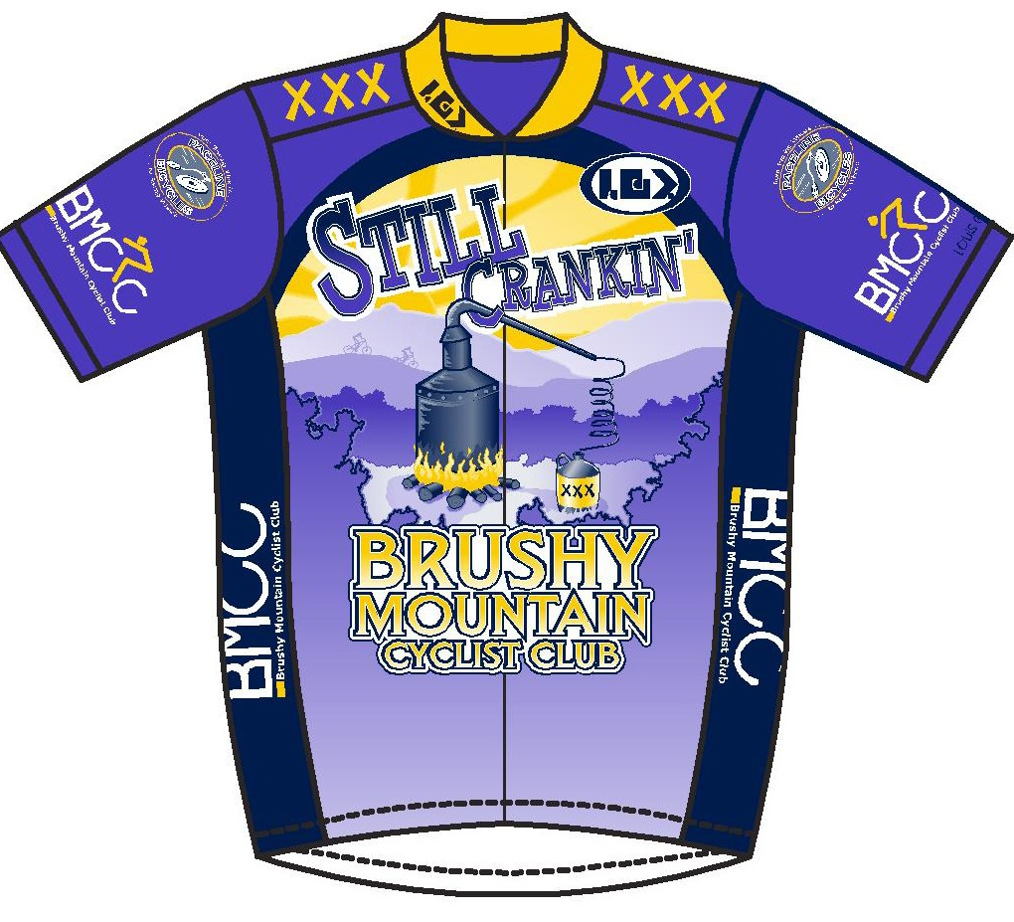
Tips Presented by
the Brushy Mountain Cyclists Club
Wilkesboro, N.C.
www.bmcc.us

Ride Safe and Enjoy the Ride!

